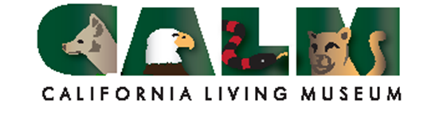
Wildlife Rehabilitation Team 2020 Application

CALM is the only Wildlife Rehabilitation Center in Kern County receives (on average) 900 animals each year that require specialized care. Annually, the financial cost and staffing must be supplemented with trained volunteers in order to continue providing this valuable community service.

We are looking for dedicated and active participation as a member of the team. The minimum age requirement is 18 years. By being selected to participate in the Rehabilitation Training Course, you are committing to assist with the Wildlife Rehabilitation Program during the 2020 rehabilitation season--the busy season is April through October; however, this is a year ‘round program.
-Training sessions are scheduled Saturday, March 21 and 22, from 2-4 p.m. at CALM. You must attend both sessions.
-If you were on the team last year, you need to attend one session for CE credit of Base Training.
-Applications are due Thursday, March 12, by 4 p.m.
Class space is limited to 30 people. You will be notified, via email Saturday, March 14, if you will be in the 2020 class. In that email, you will be provided further instructions.

(Please PRINT clearly)

Name________________________________ Phone _________________________ Email_____________________
Address__________________________________________ City _______________________ Zip _______________
Emergency contact _____________________________________phone number _____________________________

Names of all wildlife rehabilitation volunteers are submitted to the California Department of Fish and Wildlife as part of permit requirements.

There is a $20 participation charge that will cover training sessions, a t-shirt and materials which is payable (cash or check only) at the last session—March 22. As a team member you are required to provide volunteer time to the CALM rehabilitation center a minimum of eight hours a month. Please bring a notebook and pen/pencil to class with you.

The information in this application is true & correct. I understand that if I become Wildlife Rehabilitation Team member, after completing the training course, that I am making a minimum one-year commitment. I agree to uphold the mission of CALM and follow all guidelines and procedures. I give my consent for emergency attention in the event that I am unable to give my consent. I also give my consent for my image being used in still photography, video and placed in publications, advertising and social media.

Signature _________________________________________________________ Date _______________________
Submit forms via one of the following: Email: Shadams@kern.org Fax: 872-2205; Mail: 10500 Alfred Harrell Hwy, Bakersfield, 93306.
Rev: 2/7/2020-LKF

